Zhukova Valeriya

**Music Library Project Description**

The project represents the music catalog, that provides user with the following functionality: authorization and authentication, browsing music, creating playlists, adding music to the playlist. Potentially, it will have a music recommendation module.

Currently the system consists of the following compponents:

1. Music catalog service – the core application
2. Music information service will provide data on musical works: the title, performer, release year, album, length, genre; there also will be search function by the attributes mentioned earlier.
   1. GET songs by user id (the ones saved in the main playlist)
   2. GET song by id (single song record)
   3. GET songs by album, genre, performer (list)
   4. Search queries
3. User authorization/authentication service
   1. POST registration query (username, email, password)
   2. POST login (username, password)
4. User playlists service – will have the functionality for users to add music to the main playlist, or to create custom playlists
   1. GET playlists by user id
   2. GET particular playlist songs

The communication between the microservices can be displayed in the following diagram:

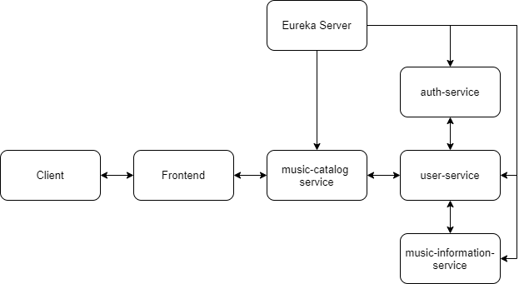

The system architecture:

